|  |
| --- |
| Soccer field at night |
| Semester Project  Online player registration system |
| |  |  |  | | --- | --- | --- | | David Nwachukwu | 6/10/24 | INFS611 ADVANCED DBMS | |

Contents

Introduction 3

1. Planning and Requirements Gathering 3

**1.1 Stakeholders Identification** 3

**1.2 Requirements Gathering** 3

**1.3 Resource Planning** 5

**1.4 Project Schedule and Milestones** 5

2. Analysis 5

**2.1 Current System Analysis** 6

**2.2 Data Flow Analysis** 6

**2.3 Business rules** 7

**2.4 Entity Identification** 7

**2.5 Relational Schema** 7

**2.6 Entity Relationship Diagram (ERD)** 8

**2.6 Data Dictionary** 10

**2.7 Requirements Validation** 14

3. Design 14

**3.1 Physical Design** 14

4. Implementation 19

**4.1 Development Environment Setup** 19

**4.2 Database Creation and Table Setup** 19

**4.3 Web Application Development** 20

**4.4 User Interface Implementation** 21

**4.5 Database Integration** 21

**4.6 Security Implementation** 21

**4.7 Email Notification Implementation** 21

**4.8 Version Control and Collaboration** 21

**4.9 Hosting and Deployment** 22

**4.10 Testing and Quality Assurance** 22

5. Testing 22

**5.1 Unit Testing** 23

**5.2 Integration Testing** 23

**5.3 System Testing** 23

**5.4 User Acceptance Testing (UAT)** 24

6. Deployment 24

**6.1 Production Environment Setup** 24

**6.2 Data Migration** 24

**6.3 System Configuration and Hardening** 24

**6.4 User Training and Documentation** 25

**6.5 Go-Live and Support** 25

7. Maintenance 25

**7.1 Monitoring and Incident Management** 25

**7.2 Bug Fixes and Patches** 25

**7.3 Enhancements and Feature Requests** 25

**7.4 Data Backup and Recovery** 26

**7.5 Performance Optimization** 26

**7.6 User Support and Training** 26

8. Limitations of the Developed System 26

**8.1 Web Hosting Integration Issues** 26

**8.2 Prototype Nature of the System** 27

**8.3 Lack of Payment Functionality** 27

**8.4 Future Enhancements and Roadmap** 27

# Introduction

The MYSAFA system is designed to streamline the registration and management of players within the South African Football Association (SAFA). This centralized system aims to prevent identity fraud, ensure accurate player records, and facilitate easy tracking and management of players across various leagues and competitions. For registration and competition management, we can follow the Software Development Life Cycle (SDLC) processes. The SDLC is a structured process that defines the stages involved in the development of software, from initial planning and analysis to deployment and maintenance.

# **1. **Planning and Requirements Gathering****

**1.1 Stakeholders Identification**

The primary stakeholders for the player registration and competition management system are:

* South African Football Association (SAFA): The governing body responsible for overseeing the development and implementation of the system.
* Coaches and Team Managers: The administrators who will use the system to register players and manage competition-related activities.
* Players: The individuals whose personal information and registration details will be stored and managed within the system.
* System Administrators: The personnel responsible for maintaining and supporting the system, including database administrators and technical support staff.

**1.2 Requirements Gathering**

Through consultations with SAFA representatives and potential end-users (coaches, team managers), the following key requirements for the MYSAFA system have been identified:

**1.2.1 Functional Requirements**

* Online Registration/Sign-up Process:
  + The system should provide a web-based interface for coaches and team managers to register players for competitions and tournaments.
  + The registration process should capture essential player information, including personal details, contact information, and relevant documentation.
* Player Record Retrieval:
  + The system should allow administrators to retrieve existing player personal records, including photographs, by entering the player's unique 13-digit South African ID number.
  + The system should interface with the South African Home Affairs database to validate and fetch player information associated with the provided ID number.
* Email Notification for Registration Approval:
  + Upon successful registration of a player by an administrator, the system should automatically send an email notification to the player's registered email address.
  + The email notification should include details of the registration and require the player to approve or deny the registration to prevent repudiation or denial of consent.
* Player Registration Record Maintenance:
  + The system should maintain a comprehensive record of all registered players, including their personal details, registration history, and associated documentation.
  + The system should provide mechanisms for updating and managing player records as needed.

**1.2.2 Non-Functional Requirements**

* Security and Access Control:
  + The system should implement robust security measures to protect player data and prevent unauthorized access.
  + Role-based access control should be implemented to ensure that only authorized personnel can access and modify specific sections of the system.
* Scalability and Performance:
  + The system should be designed to handle a large volume of user traffic and data without compromising performance.
  + The system should be scalable to accommodate future growth and expansion of the user base.
* User-Friendly Interface:
  + The system's user interface should be intuitive and easy to navigate, ensuring a seamless experience for administrators (coaches and team managers).
* Data Integrity and Consistency:
  + The system should ensure data integrity and consistency by implementing appropriate validation mechanisms and data constraints.
  + Mechanisms for data backup and recovery should be in place to safeguard against data loss.

## **1.3 Resource Planning**

To successfully develop and implement the MYSAFA system, the following resources have been identified:

* **Hardware Resources:** 
  + Web and Database Servers: Powerful servers capable of handling the anticipated user load and data storage requirements.
  + Network Infrastructure: Reliable and secure network connectivity for system access and data transmission.
* **Software Resources:** 
  + Web Development Technologies: PHP, HTML, CSS, JavaScript
  + Database Management System: MySQL or another robust relational database management system (RDBMS)
  + Development Tools: Integrated Development Environment (IDE), version control system, project management tools
* **Human Resources:** 
  + Project Manager: Responsible for coordinating and overseeing the entire project.
  + Systems Analysts: Responsible for gathering requirements, designing the system architecture, and documenting the development process.
  + Database Developers: Responsible for designing and implementing the database schema, writing SQL queries, and ensuring data integrity.
  + Web Developers: Responsible for developing the web-based user interface and integrating it with the backend database.
  + Quality Assurance (QA) Testers: Responsible for thoroughly testing the system to ensure functionality, usability, and security.
  + Technical Support Staff: Responsible for providing ongoing maintenance, troubleshooting, and user support after system deployment.

## **1.4 Project Schedule and Milestones**

A preliminary project schedule and key milestones will be established in consultation with the development team. This schedule will include target dates for completing each phase of the SDLC, including analysis, design, implementation, testing, deployment, and maintenance.

# ****2. Analysis****

Based on the information provided regarding the existing MYSAFA system and the proposed enhancements, the analysis phase will involve the following activities:

## **2.1 Current System Analysis**

The current MYSAFA system has the following limitations:

* Incomplete Player Record Retrieval:
  + When an administrator searches for a player using their South African ID number, the system does not retrieve the player's photograph from the Home Affairs database.
  + This gap in functionality provides an opportunity for potential fraud and impersonation.
* Lack of Player Registration Approval:
  + The current system does not have a mechanism in place to obtain explicit approval from players for their registration.
  + This can lead to situations where players are registered without their consent, resulting in potential repudiation or denial of consent issues.

## **2.2 Data Flow Analysis**

To address the identified limitations and meet the proposed requirements, the data flow in the new system will follow this sequence:

1. The administrator logs into the system with their credentials.
2. The administrator selects the relevant league and club for player registration.
3. The administrator searches for the player using their 13-digit South African ID number.
4. The system interfaces with the Home Affairs database to retrieve the player's personal details, including their photograph.
5. The administrator fills in any additional player details required for registration, such as contact information and address.
6. The administrator uploads any necessary documents related to the player's registration (e.g., ID copies, medical records).
7. The administrator verifies the entered details and submits the registration request.
8. Upon submission, the system sends an email notification to the player's registered email address, requesting approval for the registration.
9. The player confirms or denies the registration by responding to the email notification.
10. If the player approves the registration, the system updates the player's record in the database to reflect the successful registration.

## **2.3 Business rules**

* An administrator can manage multiple clubs, but each club can have only one administrator.
* A player can register for only one club and one league per season.
* A player's registration requires approval from the player through an email confirmation process.
* Player registration is valid for a specific league and its associated time period (start and end dates).
* All necessary documents (certified ID copy, team registration form, medical form, consent form) must be uploaded during the player registration process.
* Each player has a unique South African ID number and a SAFA ID number assigned by the system.
* Player details, including personal information and photographs, are retrieved from the Home Affairs database using the South African ID number.
* Player history, including goals scored, red cards received, and injuries, is maintained for each season.

## **2.4 Entity Identification**

Based on the data flow analysis and business rules, the following entities have been identified:

* Administrator
* Player
* League
* Club
* Registration
* Document

## **2.5 Relational Schema**

admin(AdminID, FullName, Email, Contact, Password, token, active)

club(ClubID, ClubName, Province, AdminID)

league(LeagueID, LeagueName, StartDate, EndDate, Status)

player(SouthAfricanID, firstName, lastName, sex, age, dateOfBirth, nationality, SAFAID, email, contact, photo)

documents(DocumentID, SouthAfricanID, CertifiedID, TeamRegistration, MedicalForm, ConsentForm, DateUploaded)

player_history(SouthAfricanID, SAFAID, ClubName, LeagueName, Year, Goals, RedCards, Injury)

player_details(SouthAfricanID, SAFAID, first_name, last_name, email, contact, physical_address, photo)

registration(RegistrationID, SouthAfricanID, SAFAID, ClubName, LeagueName, Status, Email, ConfirmationCode)

## **2.6 Entity Relationship Diagram (ERD)**

**Entities**:

1. **admin**: Represents the administrators of the system.
2. **club**: Represents the clubs participating in the leagues.
3. **league**: Represents the leagues in which clubs and players participate.
4. **player**: Represents the players registered in the system.
5. **documents**: Stores the documents associated with each player's registration.
6. **player_history**: Maintains the historical records of a player's performance in different seasons.
7. **player_details**: Stores the detailed information of each player, including their personal information and photograph.
8. **registration**: Represents the registration of a player for a specific club and league.

**Relationships**:

1. **admin** (1:M) ----- **club**: One administrator can manage multiple clubs, but each club can have only one administrator.
2. **club** (1:M) ------ **player**: One club can have multiple players registered, but each player can be registered with only one club at a time.
3. **club** (1:M) ------ **registration**: One club can have multiple player registrations, but each registration is associated with only one club.
4. **player** (1:1) ----- **player_details**: Each player has a one-to-one relationship with their detailed information stored in the player_details table.
5. **player** (1:M) ----- **documents**: One player can have multiple documents associated with their registration.
6. **player** (1:M) ----- **player_history**: One player can have multiple historical records across different seasons.
7. **registration** (M:1) ----- **league**: Multiple player registrations can be associated with a single league, but each registration is for a specific league.

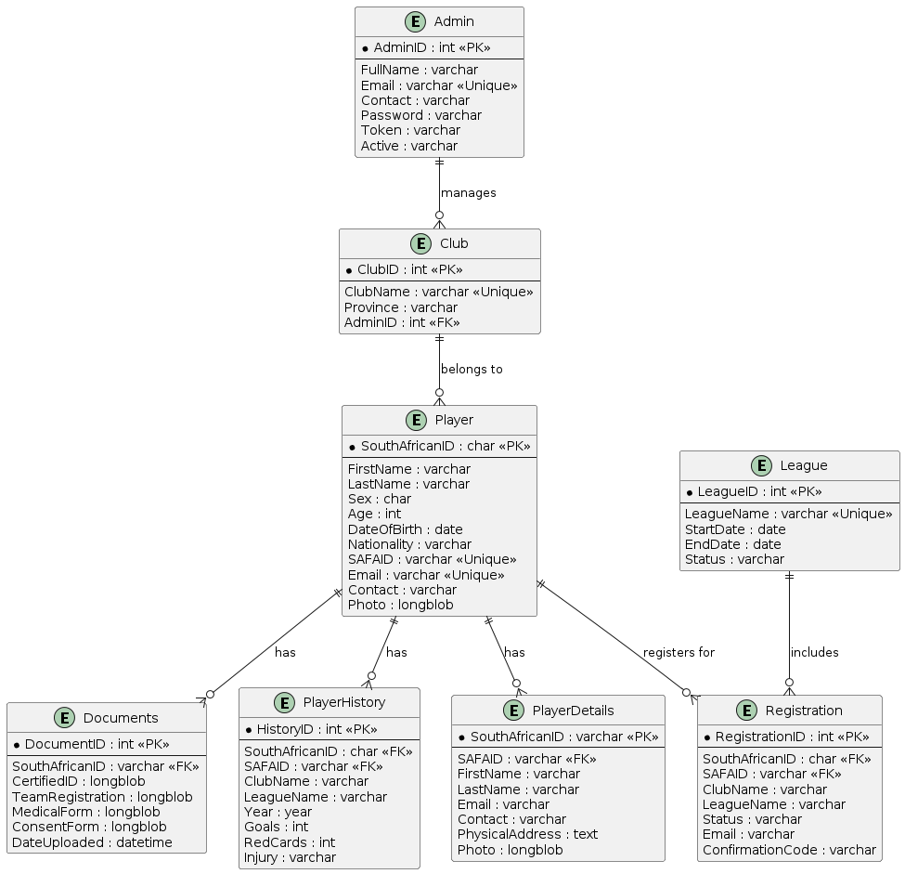

The cardinalities in the diagram indicate the relationships between the entities. For example, the (1:M) cardinality between admin and club indicates that one administrator can manage multiple clubs, while the (M:1) cardinality between registration and league indicates that multiple registrations can be associated with a single league.

## **2.6 Data Dictionary**

A preliminary data dictionary will be developed to define the entities, their attributes, and data types. This will serve as a reference for the database design and implementation phases.

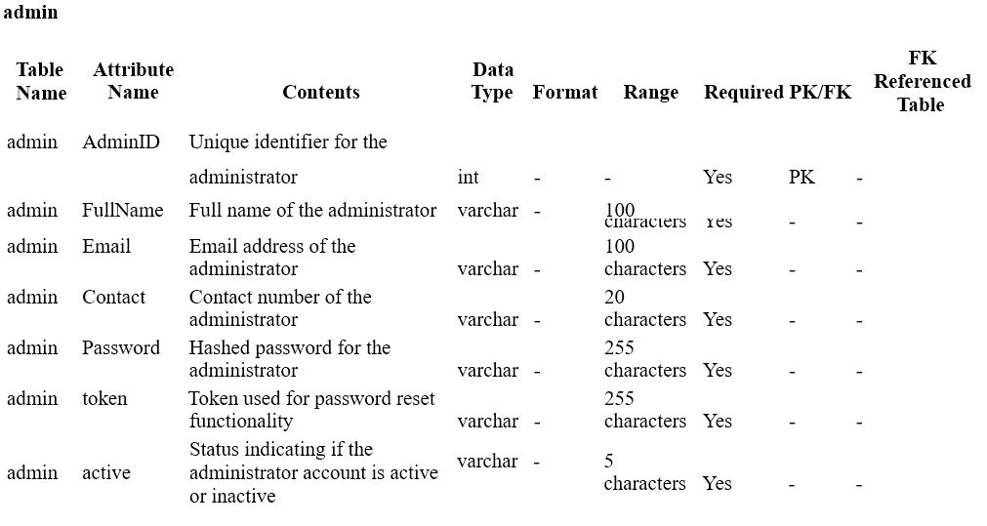

**Player**

## **2.7 Requirements Validation**

The analysis phase will involve validating the gathered requirements with SAFA representatives and potential end-users (coaches, team managers) to ensure that the proposed system meets their needs and addresses the identified limitations of the current system.

# 3. Design

## **3.1 Physical Design**

**3.1.1 Database Structure**

Based on the logical design and the provided schema, the physical database structure will be implemented using MySQL. The following SQL statements will be executed to create the tables, indexes, and constraints:

*-- Create admin table*

CREATE TABLE `admin` (

`AdminID` int(11) NOT NULL AUTO_INCREMENT,

`FullName` varchar(100) NOT NULL,

`Email` varchar(100) NOT NULL,

`Contact` varchar(20) NOT NULL,

`Password` varchar(255) NOT NULL,

`token` varchar(255) NOT NULL,

`active` varchar(5) NOT NULL,

PRIMARY KEY (`AdminID`)

) ENGINE=InnoDB DEFAULT CHARSET=utf8mb4;

*-- Create club table*

CREATE TABLE `club` (

`ClubID` int(11) NOT NULL AUTO_INCREMENT,

`ClubName` varchar(100) NOT NULL,

`Province` varchar(25) NOT NULL,

`AdminID` int(11) NOT NULL,

PRIMARY KEY (`ClubID`),

FOREIGN KEY (`AdminID`) REFERENCES `admin`(`AdminID`)

) ENGINE=InnoDB DEFAULT CHARSET=utf8mb4;

*-- Create league table*

CREATE TABLE `league` (

`LeagueID` int(11) NOT NULL AUTO_INCREMENT,

`LeagueName` varchar(100) NOT NULL,

`StartDate` date NOT NULL,

`EndDate` date NOT NULL,

`Status` varchar(20) NOT NULL DEFAULT 'Opened',

PRIMARY KEY (`LeagueID`)

) ENGINE=InnoDB DEFAULT CHARSET=utf8mb4;

*-- Create player table*

CREATE TABLE `player` (

`SouthAfricanID` char(13) NOT NULL,

`firstName` varchar(45) NOT NULL,

`lastName` varchar(45) NOT NULL,

`sex` char(6) NOT NULL,

`age` int(2) NOT NULL,

`dateOfBirth` date NOT NULL,

`nationality` varchar(45) NOT NULL,

`SAFAID` varchar(10) NOT NULL,

`email` varchar(45) NOT NULL,

`contact` varchar(15) NOT NULL,

`photo` longblob NOT NULL,

PRIMARY KEY (`SouthAfricanID`)

) ENGINE=InnoDB DEFAULT CHARSET=utf8mb4;

*-- Create documents table*

CREATE TABLE `documents` (

`DocumentID` int(11) NOT NULL AUTO_INCREMENT,

`SouthAfricanID` varchar(15) NOT NULL,

`CertifiedID` longblob DEFAULT NULL,

`TeamRegistration` longblob DEFAULT NULL,

`MedicalForm` longblob DEFAULT NULL,

`ConsentForm` longblob DEFAULT NULL,

`DateUploaded` datetime NOT NULL,

PRIMARY KEY (`DocumentID`),

FOREIGN KEY (`SouthAfricanID`) REFERENCES `player`(`SouthAfricanID`)

) ENGINE=InnoDB DEFAULT CHARSET=utf8mb4;

*-- Create player_history table*

CREATE TABLE `player_history` (

`SouthAfricanID` char(13) NOT NULL,

`SAFAID` varchar(10) NOT NULL,

`ClubName` varchar(100) NOT NULL,

`LeagueName` varchar(100) NOT NULL,

`Year` year(4) NOT NULL,

`Goals` int(11) NOT NULL,

`RedCards` int(11) NOT NULL,

`Injury` varchar(255) DEFAULT NULL,

PRIMARY KEY (`SouthAfricanID`),

FOREIGN KEY (`SouthAfricanID`) REFERENCES `player`(`SouthAfricanID`)

) ENGINE=InnoDB DEFAULT CHARSET=utf8mb4;

*-- Create player_details table*

CREATE TABLE `player_details` (

`SouthAfricanID` varchar(13) NOT NULL,

`SAFAID` varchar(50) NOT NULL,

`first_name` varchar(100) NOT NULL,

`last_name` varchar(100) NOT NULL,

`email` varchar(100) NOT NULL,

`contact` varchar(15) NOT NULL,

`physical_address` text NOT NULL,

`photo` longblob DEFAULT NULL,

PRIMARY KEY (`SouthAfricanID`),

FOREIGN KEY (`SouthAfricanID`) REFERENCES `player`(`SouthAfricanID`)

) ENGINE=InnoDB DEFAULT CHARSET=utf8mb4;

*-- Create registration table*

CREATE TABLE `registration` (

`RegistrationID` int(11) NOT NULL AUTO_INCREMENT,

`SouthAfricanID` char(13) NOT NULL,

`SAFAID` varchar(10) NOT NULL,

`ClubName` varchar(100) NOT NULL,

`LeagueName` varchar(100) NOT NULL,

`Status` varchar(50) DEFAULT 'Pending',

`Email` varchar(255) DEFAULT NULL,

`ConfirmationCode` varchar(255) DEFAULT NULL,

PRIMARY KEY (`RegistrationID`),

FOREIGN KEY (`SouthAfricanID`) REFERENCES `player`(`SouthAfricanID`),

FOREIGN KEY (`LeagueName`) REFERENCES `league`(`LeagueName`)

) ENGINE=InnoDB DEFAULT CHARSET=utf8mb4;

These statements will create the tables with the specified structure, including primary keys, foreign keys, and constraints. Appropriate indexes will be added to improve query performance based on the application's usage patterns.

**3.1.2 User Interface Design**

The user interface (UI) for the MYSAFA web application will be designed using HTML, CSS, and JavaScript. The UI will consist of the following main components:

1. **Login Page**: A secure login page for administrators to authenticate and access the system.
2. **Dashboard**: A centralized dashboard for administrators to manage player registrations, view club and league information, and access other functionalities.
3. **Player Registration Form**: A form for administrators to register new players, including fields for entering player details, uploading documents, and initiating the registration approval process.
4. **Player Management**: A section for administrators to view and manage registered players, including updating player details, reviewing player history, and handling registration approvals.
5. **Club and League Management**: Interfaces for administrators to create, update, and manage clubs and leagues, including setting league schedules and assigning clubs to specific leagues.

**Login page.**

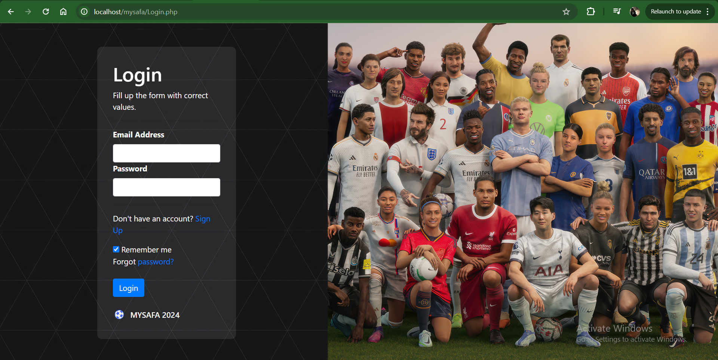

**Select league**

**Select Club from a dropdown list**

**Search and retrieve player details**

**Enter player details**

**Upload documents**

**Confirm registration**

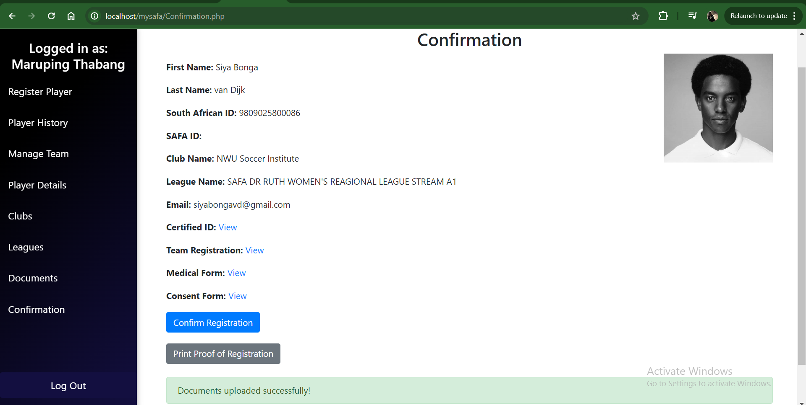

**Registration dashboard**

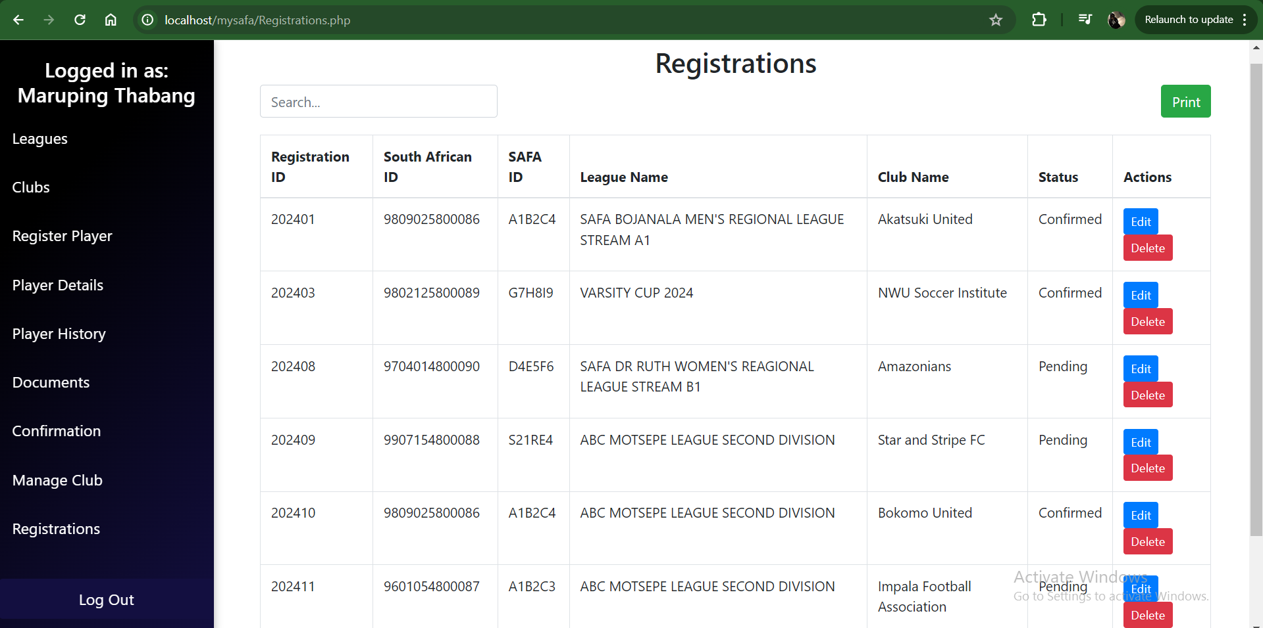

**3.1.3 Data Security, Backup, and Recovery**

To ensure data security, integrity, and availability, the following measures will be implemented:

1. **Password Hashing**: Player and administrator passwords will be securely hashed using industry-standard algorithms (e.g., bcrypt) before storing them in the database.
2. **Input Validation**: All user input will be sanitized and validated to prevent SQL injection, cross-site scripting (XSS), and other common web application vulnerabilities.
3. **Session Management**: Secure session management techniques will be employed to protect against session hijacking and other session-related attacks.
4. **Encryption**: Sensitive data, such as player documents and administrator credentials, will be encrypted both in transit and at rest using strong encryption algorithms.
5. **Access Controls**: Role-based access controls will be implemented to restrict unauthorized access to sensitive data and functionality.
6. **Database Backup**: Regular database backups will be scheduled and stored in a secure location to facilitate data recovery in case of system failures or data loss incidents.
7. **Disaster Recovery Plan**: A comprehensive disaster recovery plan will be developed to outline the procedures for restoring the system and data in the event of a major incident.

# 4. Implementation

## **4.1 Development Environment Setup**

The development environment for the MYSAFA web application will be set up using the following components:

1. **XAMPP**: A cross-platform web server solution stack that includes Apache, MySQL, and PHP. This will be used for local development and testing purposes.
2. **MySQL**: The relational database management system used for storing and managing the MYSAFA data.
3. **PHP**: The server-side scripting language used for developing the web application and interacting with the database.
4. **HTML, CSS, and JavaScript**: The front-end technologies used for building the user interface and providing interactivity.
5. **PHPMailer**: A PHP library used for sending email notifications to players during the registration approval process.
6. **GitHub**: A web-based version control and collaboration platform used for hosting the project's source code and enabling collaboration among developers.
7. **Vercel**: A cloud platform for static sites and Serverless Functions, used for hosting and deploying the MYSAFA web application.

## **4.2 Database Creation and Table Setup**

Based on the physical design outlined in the previous section, the MySQL database and tables will be created using the provided SQL statements. These statements will be executed in the MySQL environment set up as part of the XAMPP stack.

## **4.3 Web Application Development**

The MYSAFA web application will be developed using PHP as the server-side language, along with HTML, CSS, and JavaScript for the front-end components. The application will be structured using the Model-View-Controller (MVC) architectural pattern to promote code organization, maintainability, and separation of concerns.

The development process will involve the following steps:

1. **Project Setup**: The project will be initialized, and the necessary directory structure will be created to organize the application's files, including models, views, controllers, and other supporting files.
2. **Database Connectivity**: A database connection class or file will be created to establish and manage the connection between the PHP application and the MySQL database.
3. **Model Development**: Model classes will be developed to represent the entities in the system, such as players, clubs, leagues, and registrations. These classes will encapsulate the logic for interacting with the database and performing CRUD (Create, Read, Update, Delete) operations.
4. **View Development**: HTML templates and corresponding CSS stylesheets will be created to define the user interface for various pages and components of the application, such as the login page, dashboard, registration forms, and player management interfaces.
5. **Controller Development**: Controller classes or files will be developed to handle user requests, process form submissions, and interact with the respective models to retrieve or manipulate data.
6. **User Authentication and Authorization**: Mechanisms for user authentication (login and logout) and authorization (role-based access control) will be implemented to secure the application and restrict access to sensitive areas and functionality.
7. **Email Notification Integration**: The PHPMailer library will be integrated into the application to enable sending email notifications to players during the registration approval process.
8. **Input Validation and Security**: Appropriate input validation and security measures, such as sanitizing user input, preventing SQL injection, and implementing secure session management, will be implemented throughout the application.
9. **Testing and Debugging**: The application will be thoroughly tested at various stages of development, including unit testing, integration testing, and end-to-end testing, to identify and resolve any issues or bugs.

## **4.4 User Interface Implementation**

The user interface (UI) for the MYSAFA web application will be implemented based on the UI design created during the design phase. This will involve translating the design mockups into HTML, CSS, and JavaScript code, ensuring a consistent and user-friendly experience across different pages and components.

## **4.5 Database Integration**

The PHP application will be integrated with the MySQL database to enable data storage, retrieval, and manipulation. The database connectivity class or file created earlier will be utilized to establish connections and execute SQL queries from within the application's code.

## **4.6 Security Implementation**

The security measures outlined in the design phase, such as password hashing, input validation, session management, and encryption, will be implemented throughout the application to protect against common web application vulnerabilities and ensure data integrity and confidentiality.

## **4.7 Email Notification Implementation**

The PHPMailer library will be integrated into the application to facilitate sending email notifications to players during the registration approval process. This will involve configuring the email server settings, creating email templates, and triggering the email sending functionality at the appropriate points in the application's workflow.

## **4.8 Version Control and Collaboration**

The project's source code will be hosted on GitHub, a web-based version control and collaboration platform. Developers will use Git for version control, enabling them to track changes, manage branches, and collaborate effectively during the development process.

## **4.9 Hosting and Deployment**

Once the development and testing phases are completed, the MYSAFA web application will be deployed to Vercel, a cloud platform for static sites and Serverless Functions. Vercel will be configured to automatically build and deploy the application whenever changes are pushed to the GitHub repository, ensuring a streamlined and efficient deployment process.

## **4.10 Testing and Quality Assurance**

Throughout the implementation phase, the application will undergo rigorous testing to ensure its functionality, usability, and security. This will include:

1. **Unit Testing**: Individual components and functions of the application will be tested in isolation to verify their correctness and behavior.
2. **Integration Testing**: Different components and modules of the application will be integrated and tested together to ensure they interact and function correctly as a whole.
3. **Functional Testing**: The application's functionality will be thoroughly tested to ensure it meets the specified requirements and behaves as expected in various scenarios.
4. **Usability Testing**: The application's user interface and overall user experience will be evaluated by representative users to identify and address any usability issues or areas for improvement.
5. **Security Testing**: Penetration testing and vulnerability assessments will be conducted to identify and mitigate potential security vulnerabilities or weaknesses in the application.
6. **Performance Testing**: The application's performance will be tested under various load conditions to ensure it can handle anticipated user traffic and workloads without degradation in responsiveness or stability.
7. **Compatibility Testing**: The application will be tested across different web browsers, devices, and operating systems to ensure consistent behavior and compatibility.

# ****5. Testing****

The testing phase for the MYSAFA player registration and competition management system will involve multiple stages to ensure the system's functionality, usability, and security. The following testing activities will be performed:

## **5.1 Unit Testing**

Unit testing will be conducted to verify the correctness of individual components or modules of the system. This includes testing the functionality of the following components:

* **Database Queries**: Test cases will be developed to ensure that SQL queries for inserting, updating, deleting, and retrieving data from the database are working as expected.
* **Business Logic**: The business logic implemented in the server-side code (PHP) will be tested to validate that the system adheres to the defined business rules and requirements.
* **User Interface Components**: Individual UI components, such as forms, buttons, and navigation elements, will be tested to ensure proper rendering and functionality.

## **5.2 Integration Testing**

Integration testing will be performed to verify the correct interaction and communication between different components or modules of the system. This includes testing scenarios such as:

* **Database Integration**: Validate the integration between the web application and the database, ensuring that data is retrieved, stored, and updated correctly.
* **Email Notification Integration**: Test the integration with the PHPMailer library to ensure that email notifications for player registration approval are sent correctly.
* **Front-end and Back-end Integration**: Test the integration between the front-end (UI) and back-end (server-side code) components, ensuring that user interactions and data flow seamlessly between the two layers.

## **5.3 System Testing**

System testing will be conducted to test the entire MYSAFA system as a whole, including end-to-end scenarios. This will involve testing the following aspects:

* **Functional Testing**: Verify that all functional requirements of the system are met, including player registration, club and league management, player history tracking, and reporting capabilities.
* **Usability Testing**: Evaluate the system's user-friendliness, navigation, and overall user experience.
* **Performance Testing**: Assess the system's performance under various load conditions, including concurrent user access and large data volumes.
* **Security Testing**: Perform vulnerability assessments and penetration testing to identify and mitigate potential security risks, such as SQL injection, cross-site scripting (XSS), and unauthorized access attempts.

## **5.4 User Acceptance Testing (UAT)**

User Acceptance Testing (UAT) will be conducted by involving stakeholders, such as SAFA representatives, coaches, and team managers. During UAT, end-users will have the opportunity to test the system in a simulated production environment and provide feedback on its functionality, usability, and alignment with their requirements.

# ****6. Deployment****

After successful testing and stakeholder approval, the MYSAFA system will be deployed to the production environment. The deployment phase will involve the following activities:

## **6.1 Production Environment Setup**

A production-grade server environment will be set up to host the MYSAFA web application and database. This environment will be configured with appropriate security measures, such as firewalls, SSL/TLS encryption, and access controls.

## **6.2 Data Migration**

If there is any existing data from a previous system or pilot deployment, it will be migrated to the new production database using secure and reliable migration techniques.

## **6.3 System Configuration and Hardening**

The production environment will be configured and hardened to ensure optimal performance, security, and reliability. This includes activities such as:

* Configuring web server settings (e.g., Apache)
* Optimizing database settings for performance and security
* Implementing caching mechanisms for improved response times
* Enabling logging and monitoring mechanisms
* Applying security patches and updates

## **6.4 User Training and Documentation**

Comprehensive user training and documentation will be provided to SAFA personnel, coaches, and team managers to ensure a smooth transition to the new system. This includes:

* User manuals and guides
* Training sessions or workshops
* Online help resources and knowledge base

## **6.5 Go-Live and Support**

After completing the necessary preparations, the MYSAFA system will be made available for use by end-users. A dedicated support team will be available to address any issues or queries that may arise during the initial go-live period.

# ****7. Maintenance****

The maintenance phase is crucial to ensure the long-term reliability, performance, and security of the MYSAFA system. The following maintenance activities will be performed:

## **7.1 Monitoring and Incident Management**

Continuous monitoring of the system's performance, security, and availability will be conducted. Appropriate monitoring tools and alerts will be set up to proactively identify and address any issues or incidents that may arise.

## **7.2 Bug Fixes and Patches**

Any bugs or defects identified during the system's operation will be promptly addressed and fixed. Security patches and updates will be regularly applied to the system to mitigate potential vulnerabilities and threats.

## **7.3 Enhancements and Feature Requests**

As the system evolves, new feature requests or enhancements may arise from stakeholders or end-users. These requests will be evaluated, prioritized, and implemented as part of the maintenance phase, ensuring that the system remains up-to-date and aligned with changing requirements.

## **7.4 Data Backup and Recovery**

Regular data backups will be performed to ensure the availability of critical data in case of system failures or data loss incidents. Disaster recovery procedures will be tested and updated periodically to maintain the system's resilience and business continuity.

## **7.5 Performance Optimization**

Continuous performance monitoring and optimization will be carried out to ensure that the system remains responsive and efficient as the user base and data volumes grow over time. This may involve activities such as database indexing, caching mechanisms, and code optimizations.

## **7.6 User Support and Training**

Ongoing user support and training will be provided to address any questions or issues faced by end-users. New user manuals and training materials will be developed as needed to accommodate system updates or changes.

# ****8. Limitations of the Developed System****

While the MYSAFA player registration and competition management system has been designed and developed to meet the specified requirements, there are certain limitations that should be acknowledged:

## **8.1 Web Hosting Integration Issues**

Currently, the system is unable to be deployed live due to web hosting integration issues. The development team has encountered challenges in integrating the application with a production-grade web hosting environment. These issues may include compatibility problems, server configuration complexities, or security constraints.

To address this limitation, the development team will continue to work on resolving the web hosting integration issues. This may involve exploring alternative hosting solutions, optimizing the application for specific hosting environments, or collaborating with hosting providers to ensure seamless integration.

## **8.2 Prototype Nature of the System**

It is important to note that the current version of the MYSAFA system is intended to serve as a prototype. While the system has been developed to meet the core requirements, it is expected that further enhancements and improvements will be made incrementally.

As a prototype, the system may have certain limitations in terms of scalability, performance, or feature completeness. These limitations will be addressed through iterative development cycles, incorporating feedback from stakeholders and end-users.

## **8.3 Lack of Payment Functionality**

The current version of the MYSAFA system does not include a payment functionality. As per the requirements, each player registration is associated with a fee of 10.00. However, the system does not currently facilitate the collection and processing of these payments.

To address this limitation, the development team will need to integrate a secure and reliable payment gateway or payment processing system. This may involve integrating with third-party payment service providers or developing a custom payment module within the application.

## **8.4 Future Enhancements and Roadmap**

While the limitations mentioned above are present in the current version of the system, they are expected to be addressed through ongoing development and enhancement efforts. The development team has plans to continuously improve and expand the system's capabilities based on stakeholder feedback and evolving requirements.

Some potential future enhancements and features that may be considered include:

* Integration with additional external data sources or systems (e.g., other sports associations, government databases)
* Advanced reporting and analytics capabilities
* Mobile application development for improved accessibility and user experience
* Integration with social media platforms for player promotion and community engagement
* Support for multi-language and localization